Transport Model Instructions (March 23, 2001).

Caveat: No attempt has been made to make this model comprehendable by anyone but me (J. Sperry). It includes many redundant inputs/incomplete outputs/cryptic codings and behaviour/useless and non-de-bugged outputs that I know to ignore/etc. It is updated, modified, frequently by me for purposes at hand. This is for lack of time to produce a more user-friendly, flexible, multi-purpose version. Funding and interest permitting, such a version will eventually be provided. Questions: 801 585 0379, sperry@biology.utah.edu.

Brief description. The model computes the flows and pressures in the soil-leaf hydraulic continuum for a given transpiration rate and a given bulk soil moisture profile in the rooting zone. In this version, several successive bulk soil moisture profiles can be run in one batch. This is supposed to represent a seasonal course of soil moisture. This version retains a “memory” of the previous pressure that each conducting component has been subjected to and modifies the xylem vulnerability curve to reflect any cavitation that has occurred. Thus—it assumes no xylem refilling after a drought or stress event. So—if your data include a severe drought followed by a rise in the soil water potential, the model remembers the drought, and keeps the conductances of the plant at the drought value. Similarly, as soil layers dry out from the top down, the model kicks out non-functional shallow root layers as they fail to conduct water.

If you think that refilling is occurring, (i.e., if this behaviour fits post-drought data better), I have other versions of the model that don’t do this, or you can run each date separately from the initial values and collate the results.

As presently configured, only steady-state flow-pressure relationships are outputted, although the model runs in both steady- and non-steady state modes. The coding is in visual basic for excel—just a massive macro. Hit the “run” button to go.

The continuum is assumed to be composed of a specified number of “modules” (see Fig. below). Each module consists of a single variable axial resistance that represents a section of trunk or descending root, and a single variable lateral resistance which represents the lumped (in parallel) resistance from trunk section to leaves or from vertical root section to soil. Modules are stacked to represent a canopy of different layers, or a root system of different layers. The root surface is linked to bulk soil via a rhizosphere resistance that is independent for each root system layer. Note: in practice I have only used multiple modules in the root system, so I cannot testify to whether a layered canopy will work w/o debugging.
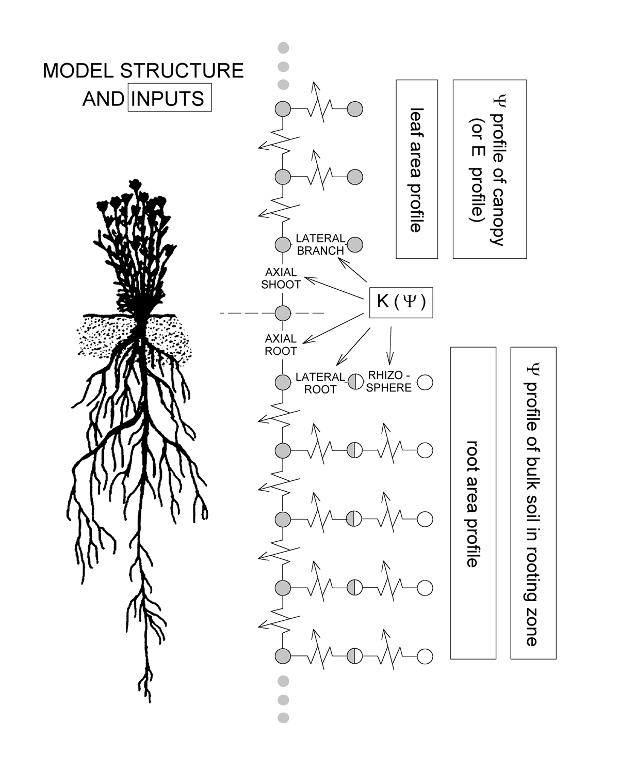

The main inputs are (and many are redundant):

a. soil properties for estimating soil conductivity (K) as a function of soil matric potential (P).
b. xylem cavitation resistance—the basis of the K(P) function in the plant.
c. saturated soil-canopy leaf-specific hydraulic conductance (k), including the predawn leaf P, midday transpiration rate (E) and midday leaf P at the time k was determined.
d. proportion of k in root vs. shoot system
e. number of root vs. shoot modules.
f. ratio of root xylem conductivity per root area in lateral vs. axial roots.
g. ratio of shoot xylem conductivity per leaf area in lateral vs. axial stems.
h. relative lengths of lateral vs. axial components in root and shoot systems.
i. leaf area profile for each canopy layer
j. root area profile for each root system layer
k. bulk soil P for each root system layer and date
l. measured E and measured leaf P for each date (optional)
m. Root-to-leaf area ratio for each date, including at saturated k.
n. relative leaf area for each date (optional)
o. fraction of absorbing root area

The main outputs are given for each date (up to 20 successive dates):

a. Maximum hydraulically permissible steady-state transpiration rate (Ecrit)
b. Associated minimum leaf xylem pressure (Pcrit)
c. Conductances at critical point for all conductance elements
d. saturated conductances for each conductance element
e. If midday E and P are inputted, the model outputs corresponding predicted values of P and E. This allows the model to be tested against measured values, and also to extend predictions of actual canopy water use to any conditions if a reasonable estimate of leaf P can be made.
f. If midday E and P are inputted, the model predicts the corresponding conductances of all conducting elements at these values.

Guide to the input/ouput page (starting with upper)

1. This block are the main soil inputs.

a. GMP is the geometric mean particle size in mm (from soil texture triangle)
b. GSD is the geometric standard deviation of particle size (from triangle)
c. BD is bulk density—usually near 1.3 in these units
d. silt fraction and clay fraction from textural analysis, or triangle.

These inputs are used to compute the “b” value for estimating the soil’s moisture release properties and K(P) function (see Sperry 1998). If moisture release data are in hand, then the “b” value can be deduced from a curve fit to these data, and the soil texture data below can be chosen to give the same b value. I know this is not very efficient, but that’s the way it is set up at the moment.

GMP, mm
GSD
BD, Mg/m3
silt fraction
clay fraction

2. The soil parameters below are computed by the model—you do not enter them.

a. Ye is the air entry potential
b. ks, the saturated conductivity
c. the b value
d. Ws, the saturated water content
e. total volume, is the total soil volume. This last term can be ignored for steady-state simulations for which this version is set up.

Ye, kPa |  | -1.11803
ks, mol/s MPa m |  | 40.064
b |  | 4.536068
Ws, moles/m3 |  | 28301.89
total volume,m3 |  | 1.2495

3. The following are inputs for the vulnerability curves for plant xylem. They are curve fitting parameters for a weibull function fit to the vulnerability curve data where MPa units are used for xylem pressure, and % loss of conductivity is used to represent conductance data (see Sperry et al. 1998). The “b” value is the xylem pressure (absolute) at 63% loss of conductivity. The “c” value is related to the slope of the weibull function. “lat root” refers to the lateral root modules, and would represent a curve of the smaller diameter roots. “ax root” are axial roots, or larger roots. “ax shoot” would be major branches, and “lat. shoot” are minor branches. If only one curve is available, enter it across the board. If only one root or one shoot curve is available, enter for all root or shoot modules.

Plant parameters
 |  | lat root | ax root | ax shoot | lat. Shoot
Weibull b value |  | 7.93 | 7.93 | 8.95 | 8.95
Weibull c value |  | 2.15 | 2.15 | 7.21 | 7.21

4. Below are inputs indicating the number of root or shoot modules represented. There can be 10 max. of each (though I have effectively obscured the space for the 10th).
The first three rows are for the shoot. Fraction of leaf area represents the fraction of the total leaf area in each canopy layer. Length of shoot laterals is the length of the lateral element of each module RELATIVE TO THE TOTAL LENGTH OF ALL AXIAL MODULES (length of trunk), where this total length = 1. Length of shoot axials is the length of the axial element of each shoot module RELATIVE TO THE TOTAL LENGTH OF ALL AXIAL MODULES (length of trunk), where this total length = 1.
The final three rows are for the root. Fraction of root area represents the fraction of the total root area in each root layer. Length of root laterals is the length of the lateral element of each module RELATIVE TO THE TOTAL LENGTH OF ALL AXIAL MODULES (max. depth of roots), where this total length = 1. Length of root axials is the length of the axial element of each root module RELATIVE TO THE TOTAL LENGTH OF ALL AXIAL MODULES (max. depth of roots), where this total length = 1.

 |  | modules of shoot and root system (10 max) starting from ground
 |  | 1 | 2 | 3 | 4 | 5 | 6 | 7 | 8 | 9
fraction of leaf area |  | 1
length shoot laterals |  | 1
length shoot axials |  | 1
fraction of root area |  | 1
length root laterals |  | 1
length root axials |  | 1

5. The following are the soil water potentials (matric) in MPa for each date (1-20) and each root layer (columns from left to right, shallow to deep).

soil potentials:
1
2
3
4
5
6
7
8
9
10
11
12
13
14
15
16
17
18
19
20

6. This block are either inputs that rarely need adjustment, or outputs of limited significance.

a. “soilshells” is the number of cylindrical conducting elements representing the rhizosphere. A minimum of 4 for good results, maximum of 10. The fewer the number, the faster the model runs.
b. “Time step” in seconds is the time step for the model. This version runs until steady-state conditions are established at each transpiration rate. Time steps are thus irrelevant.
c. The “Einc.” is the increment by which the model increases E. For each date, E is increased from zero to Ecrit, creating a complete E vs. P trajectory for the date. This is the basis for predicting the water use from a give P, or the P from a given E rate. The smaller the E increment, the more accurate the model. Usually, however, 0.01 is fine.
d. “Maximum plant k” is an output of the maximum leaf specific hydraulic conductance in the plant (excluding the rhizosphere).
e. “Maximum rhizosphere k” is an output of the maximum rhizosphere hydraulic conductance on a leaf-specific basis.
f. “Maximum total k” is an output of the maximum soil-leaf leaf-specific conductance, and should equal the inputted saturated k.
g. “root density” is an output of the root length density based on the soil volume read-out. Ignore this, as soil volume is not relevant in this version of the model.

simulation parameters
soilshells | 4
timestep,s | 3600
E inc. | 0.01
maximum plant k |  | 0.94
maximum rhizo k |  | 1.95E+10
maximum total k |  | 0.94
root density (m/m3) |  | 12732.41

7. The following are a hodgepodge of inputs, some of which are rarely changed, others must be changed with each run.

a. “initial Q” is the initial flow rate through the system (not leaf-specific). It is set very low and usually doesn’t need attention.
b. “rhizosphere width” is the width from soil surface to bulk soil. It is set to 5 mm, but can be adjusted for sensitivity analysis.
c. “frac. absorbing length” is the fraction of the total root area that is absorbing. Default is 1.
d. “Capacitance” is the tissue capacitance of the plant on a leaf area basis. It is irrelevant for this steady-state version of the model.
e. “axK:latK, shoot modules” is the ratio of the leaf-specific conductivity of axial vs. lateral components of the shoot modules. I usually set this to 1, although lateral branches typically have lower leaf specific conductivity than main branches.
f. “axK:latK, root modules” is the ratio of the root area-specific conductivity of axial vs. lateral components of the root modules. For lack of information on this, I set to 1.
g. “%total R in root system” is the % of the saturated (minimum) leaf-specific conductance of the soil-leaf continuum that is in the root system. Most woody plants seem to hover around 50%, but sensitivity can be done here.
h. “saturated kl for whole plant” this is the saturated leaf-specific conductance of the soil-to-leaf continuum. It should represent the value at the beginning of a measurement series for a growing season, for example.
i. “modeled value of kl” is outputted by the model. It takes the inputed conductance, divides it up into all the components given the rules inputed, and adds them back together. The modeled value should approach the inputted one.
j. “e at saturated kl” This is just the transpiration rate at the time of the saturated kl measurement.
k. “lai at sat kl” This is the leaf area index at the time of the saturated kl measurement. It can be set to 1, and subsequent changes in leaf area adjusted accordingly for each date.
l. “ar:al at sat kl” This is the leaf area to root area at the time of the saturated kl measurement.
m. “pd at sat kl” This is the predawn xylem pressure at the time of the saturated kl measurement.
n. “midday at sat kl” ditto for the midday leaf xylem pressure.

The next 4 inputs are related to how the model divides the total continuum conductance into the axial and lateral components. It does so by assuming an initially large root and shoot conductivity, and then decrementing each until the total continuum conductance equals what was measured. These may need to be adjusted to make the model run with new inputs. You just have to keep fooling with them to hit the right range. When you’re wrong, either the program runs forever, crashes, or gives a saturated conductance that does not match your input. As the this loop runs, you can see the root collar water potential falling to the target value, followed by the shoot.

o. “initial conductivity, root” This line is the initial conductivity of the root
p. “decrement, root” This is the interval by which the root conductivity is decreased each loop.
q. “initial conductivity, shoot” This is the initial conductivity of the shoot
r. “decrement, shoot” This is the interval for decreasing shoot conductivity

initial Q, mmol/s |  |  | 0.0001
rhizosphere width (mm) |  |  | 5
frac. absorbing length |  |  | 1
Capacitance, mol/MPa m2 |  |  | 0.01 | (on leaf area basis)
axK:latKl, shoot modules |  |  | 1 | (conductivities)
axKr:latKr, root modules |  |  | 1 | (conductivities)
% total R in root system |  |  | 50
saturated kl for whole plant |  |  | 1 | mmol s-1 m-2 MPa-1
modelled value of kl |  |  | 0.99906958
e at saturated kl |  |  | 1 | mmol s-1 m-2
lai at sat kl |  |  | 1
ar:al at sat kl |  |  | 10 |  | run
pd at sat kl |  |  | -0.1 | MPa
midday at sat kl |  |  | -1.1 | MPa
initial conductivity,root |  |  | 5
decrement,root |  |  | 0.01
initial conductivity, shoot |  |  | 10
decrement, shoot |  |  | 1
 | -1.10093 | Pleaf =
 | -0.60087 | Proot=

9. This block is the computed saturated conductances for each component in the continuum (mmol/s MPa). The module number starts from ground level, each with its axial and lateral component. Shoot modules do not have a rhizosphere component, of course. Note that module “2” is not shown, this is because that represents the root collar in the way the program keeps track of the modules. An inconsistency with the input numbering system, I know.

SATURATED K'S
module | axial k's | lat k's | rhiz k
1 | 3.9995 | 3.9995
3 | 4.000011 | 4.000011 | 1024124800

10. This block are additional outputs/inputs for each sampling date (= run) as numbered in the left column to match the corresponding inputs of the soil moisture profile (block 5, above).
a. klpred, is an output of the predicted soil-to-leaf conductance, but I think this has a bug in it right now so ignore it.
b. “MD” is the midday leaf pressure—if this is inputted, the model will output a prediction of E to match under “Epred”
c. “Al” is the leaf area—but this is really just to show any relative changes in leaf area—so if there is data showing changes in leaf area between sampling dates, this should be included here. Otherwise, just enter 1 for every date to show no change in leaf area. When all leaf areas are inputted as 1, the model just works with predicted flow rates per plant.
d. “Al:Al” is the outputted change in root-leaf area ratio for each sampling date based on the initial Ar:Al inputted (8. l., above). It is calculated by the model and outputted.
e. “E” is the inputted value of the measured midday transpiration rate, if available. When this column is entered, the model outputs a corresponding prediction of the midday leaf xylem pressure (“ppred”).
f. “Epred” is the outputted predicted transpiration rate based on the inputted midday xylem pressure. When the model is working, this agrees relatively well with E.
g. “Ecrit” is the maximum steady-state E predicted for each date.
h. “ppred” is the outputted predicted leaf pressure based on midday E—the converse of the Epred measurement.
i. “pc” is the leaf xylem pressure associated with Ecrit—the minimum permissible pressure w/o hydraulic failure.

 |  |  |  |  |  |  |  | 9.8 | -1.71859
run | klpred | MD |  | Al | Ar:Al | E | E pred | Ecrit | ppred | pc
1 |  |  |  | 1 | 10 |  |  | 8.020188 |  | -11.3625
2
3
4
5
6
7
8
9
10
11
run
12

13
14
15
16
17
18
19
20

11. These blocks output the conductances of each model component at Ecrit (left) and at the midday E or P as inputted (right) for each date or “run”. When no measurements are available, there are no predicted outputs (all = 0).

Also shown are pressures for the lateral canopy modules, and rhizosphere flux for the lateral root modules. The rhizosphere flux shows the relative water use from the different soil layers.

ECRIT K'S and PSI'S |  |  |  |  |  |  | K's at Predicted P's and E's
run | module | axial k's | lat k's | P's, rhiz k | rhiz flux |  | run | module | axial k's | lat k's | rhiz k | rhiz flux
1 | 1 | 2.83498 | 1.078099 | -9.38546 |  |  | 1 | 1 | 0 | 0
 | 3 | 2.642115 | 3.099008 | 0.932307 | 3.149832 |  |  | 3 | 0 | 0 | 0 | 0
2 | 1 | 2.83498 | 1.078099 | -9.38546 |  |  | 2 | 1 | 0 | 0
 | 3 | 2.642115 | 3.099008 | 0.932307 | 3.149832 |  |  | 3 | 0 | 0 | 0 | 0
3 | 1 | 2.83498 | 1.078099 | -9.38546 |  |  | 3 | 1 | 0 | 0
 | 3 | 2.642115 | 3.099008 | 0.932307 | 3.149832 |  |  | 3 | 0 | 0 | 0 | 0
4 | 1 | 2.83498 | 1.078099 | -9.38546 |  |  | 4 | 1 | 0 | 0
 | 3 | 2.642115 | 3.099008 | 0.932307 | 3.149832 |  |  | 3 | 0 | 0 | 0 | 0
5 | 1 | 2.83498 | 1.078099 | -9.38546 |  |  | 5 | 1 | 0 | 0
 | 3 | 2.642115 | 3.099008 | 0.932307 | 3.149832 |  |  | 3 | 0 | 0 | 0 | 0
6 | 1 | 2.83498 | 1.078099 | -9.38546 |  |  | 6 | 1 | 0 | 0
 | 3 | 2.642115 | 3.099008 | 0.932307 | 3.149832 |  |  | 3 | 0 | 0 | 0 | 0

12. This block shows the % loss in conductivity at predicted midday pressures (left) and at the Pcrit value (right) for each run. It looks like only one set of components is shown—lat branch, trunk, tap, lat root. I don’t remember which module this is for—if you use this, you should ask about it.

% LOSSES at Predicted P's |  |  |  |  | % LOSSES at critical P's
lat. Branch | trunk | tap | lat. Root |  | lat. Branch | trunk | tap | lat. Root
100 | 100 | 100 | 100 |  | 73.04417 | 29.11664 | 34.07899 | 22.67948
100 | 100 | 100 | 100 |  | 73.04417 | 29.11664 | 34.07899 | 22.67948
100 | 100 | 100 | 100 |  | 73.04417 | 29.11664 | 34.07899 | 22.67948
100 | 100 | 100 | 100 |  | 73.04417 | 29.11664 | 34.07899 | 22.67948

13. Other outputs. The model has other outputs—basically: pressure, flow, and conductivity for each component gradients for each component at each time step and E increment for each date. Any particular output can be selected—but you need to understand the code to get it to be outputted for you. Good luck!

